Project Design Phase
Problem – Solution Fit Template

Date | 8 February 2026
Team ID | LTVIP2026TMIDS26598
Project Name | Prevent User Deletion If Assigned to Incident
Maximum Marks | 2 Marks

Problem – Solution Fit Template:
In IT Service Management systems like ServiceNow, administrators often face issues such as:
• Users who are assigned to active incidents being accidentally deleted.
• Loss of incident ownership when assigned users are removed.
• Workflow disruption due to broken references between User and Incident tables.
• Data inconsistency affecting reporting and accountability.
• Manual monitoring required to prevent risky deletions.
This creates operational risk and reduces system reliability.
Purpose:
The Prevent User Deletion If Assigned to Incident project addresses this issue by:
• Implementing a Before Delete Business Rule on the sys_user table.
• Automatically checking the incident table using GlideRecord before deletion.
• Blocking deletion if the user is assigned to one or more incidents.
• Displaying a clear error message to the administrator.
• Ensuring data integrity and workflow continuity within ServiceNow.

Solution Fit:
This solution:
• Prevents accidental deletion of critical user records.
• Maintains proper incident ownership.
• Protects system workflow and reporting accuracy.
• Reduces manual administrative effort.
• Strengthens ServiceNow data governance and reliability.

Template:
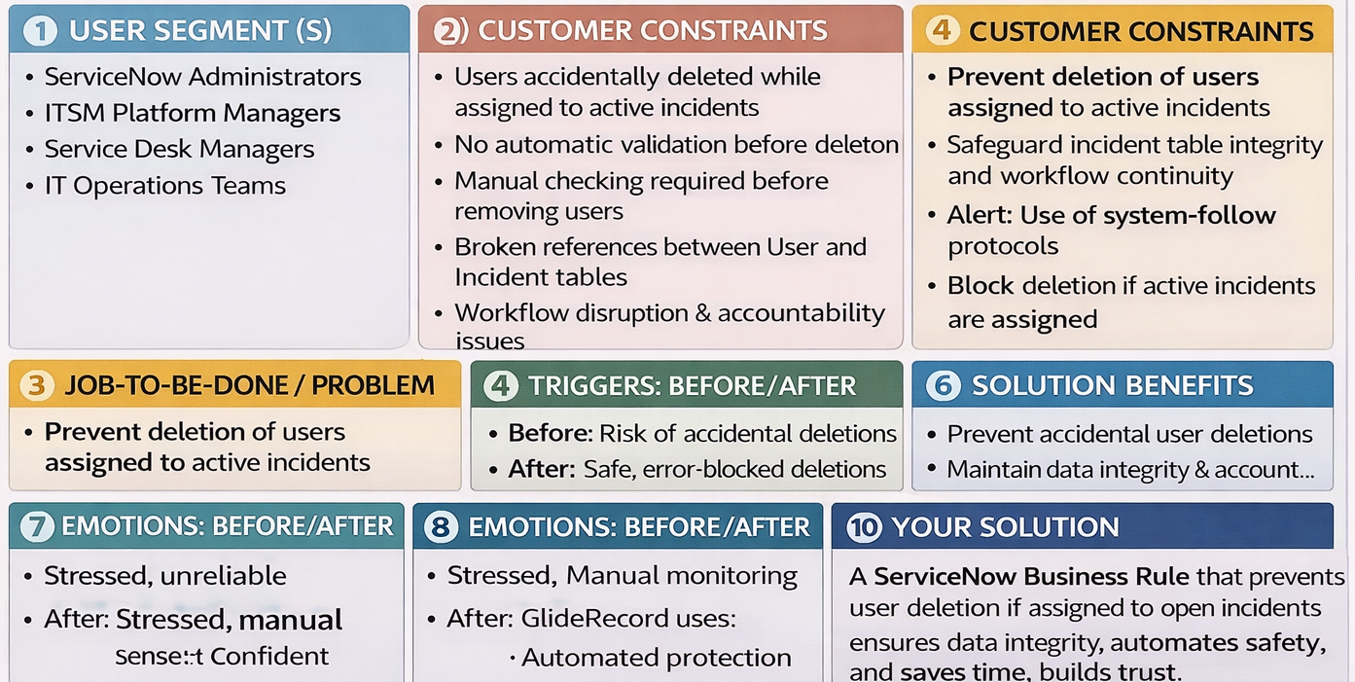

References:
- https://www.ideahackers.network/problem-solution-fit-canvas/
- https://medium.com/@epicantus/problem-solution-fit-canvas-aa3dd59cb4fe

